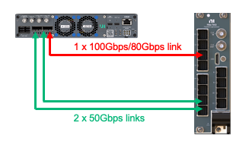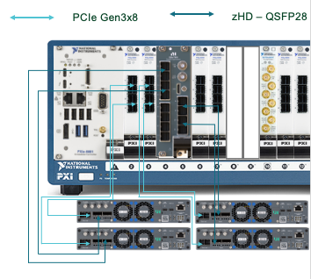

IC4C IPA: USRP X410 and PXIe-790x FPGA Streaming Example

Enable the full channel and full bandwidth streaming capability for USRP X410.

Executive Summary:
The requirements of the latest generation of wireless prototyping are significantly higher than those of previous generations. Engineers and researchers require a powerful research platform which is equipped with a reference design for rapid prototyping.
We have feedback from customers on the gap and requirements to have full channels and full bandwidth IQ streaming and processing for USRP X410 with NI-USRP driver. The gap comes from the data rate limitation of PXIe Gen3 interface. The alternative approach is using QSPF28 digital interface to stream the IQ samples to PXIe-7903 for FPGA for coprocessing. However, it brings up the technical challenge of high-speed Aurora data streaming with flow control. This streaming example is to solve this challenge and provide the ready-to-run demo example to make USRP X410 and PXIe-7903 work together with maximum performance. It provides an open reference design for wireless research and prototyping with 6G and SIGINT applications including MIMO, communication and sensing, etc.

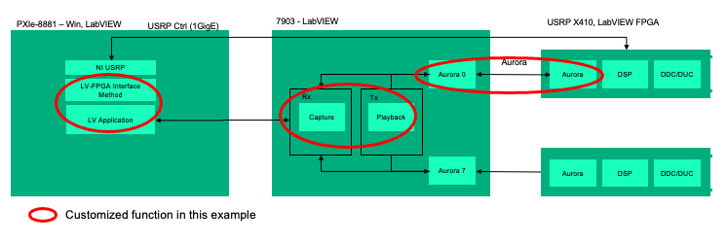
Figure 1: System architecture showing customized functions

Contacts:
CIC Growth Manager: Hang Cao
CIC System R&D: Tianming Liang
Last Updated: May 9, 2025

When?

Important Dates:

Date | Detail
May 9, 2025 | IPA Sent

Who:

Industries and Application Alignment
Aero/Defense/Gov | Semiconductor | Academic Research | Transportation
SIGINT applications in government research institute. |  | 5G / 6G Wireless testbeds for next-generation wireless such as massive MIMO, Integrated Sensing & Communications, etc.
Electrical Machinery/Equipment | Energy | Electronics (non-Semi) | Life Sciences
 |  | 5G / 6G Wireless testbeds in labs.

What is it?

Overview

Product Example for USRP X410 and PXIe-7903 streaming. The PXIe-7902 is also supported as some customers cannot purchase PXIe-7903 due to TC issues.

Configuration:
- Hardware List：
Hardware | PN | Description
USRP X410 | 787272-01 | ETTUS USRP X410 (4 TX AND 4 RX, 400MHZ BW, 1 MHZ TO 7.2 GHZ SDR, GPSDO)
PXIe-7903 | 788917-01 | PXIE-7903 FPGA CO-PROCESSOR
zHD Cable | 788928-02 | zHD to QSFP28
Table 1: Hardware configuration
- Example code features：
  - 400MHz, 4 channels on USRP-X410 TRX streaming to PXIe-7903 with QSFP28 and processing in FPGA.
  - Aurora streaming with flow control
  - FPGA can be customized for more applications.
Applications:
- MIMO and Ultra-Massive MIMO FR3
- Integrated Sensing and Communication
- Channel Emulation.

HW Technical Specs and Diagram

USRP X410
- QSFP28 Capabilities
  - 100Gbps/50Gbps streaming without flow control (shipping CLIPs)
  - 80Gbps/50Gbps streaming/framing with/without flow control
The maximum raw data throughput demand is: 4 ports * (122.88MHz * 4spc) * 32bit = 62.91456 Gbps. There are 2 options to meet the demand:
Option1：2 QSFP28 Ports * 50Gbps
Option2：1 QSFP28 Port * 100Gbps/80Gbps

PXIe-7903
- ZHD Capabilities
  - 100Gbps/80Gbps/50Gbps streaming/framing with/without flow control (SlicGen CLIPs)

Aurora link speed mapping table
1 Lane | 12.5Gbps | 20Gbps | 25Gbps
4-Lane Port | 50Gbps | 80Gbps | 100Gbps
Table 2: Aurora Link Mapping Table

Value Proposition

- Full speed streaming of USRP X410. Without this feature, USRP X410 can only operate at 250MHz 4ch, as the PXIe-Gen3 speed has limitation.
- FPGA customization was realized using PXIe-7903 with very large FPGA resources, which enables customers and partners to do DIY applications.
- PXIe-7903 can connect with multiple units of USRP X410 and this example is the key technical path to enable multi-channel MIMO and channel simulation.

Selling and Licensing

- The selling strategy will be promoted by application demos and promote through sales and marketing channel on SDR product, including:
  - Wireless communication signal transmission and demodulation.
  - MIMO Communication.
  - RF signal generation and channel simulation.
- There is no license for this demo code, it is free, see the last part for resources. The product selling with a simple system will enable sales and partners to sell USRP X410 and PXIe-7903 together and customers can customize the demo code for their purpose.

Customer-Facing Demo

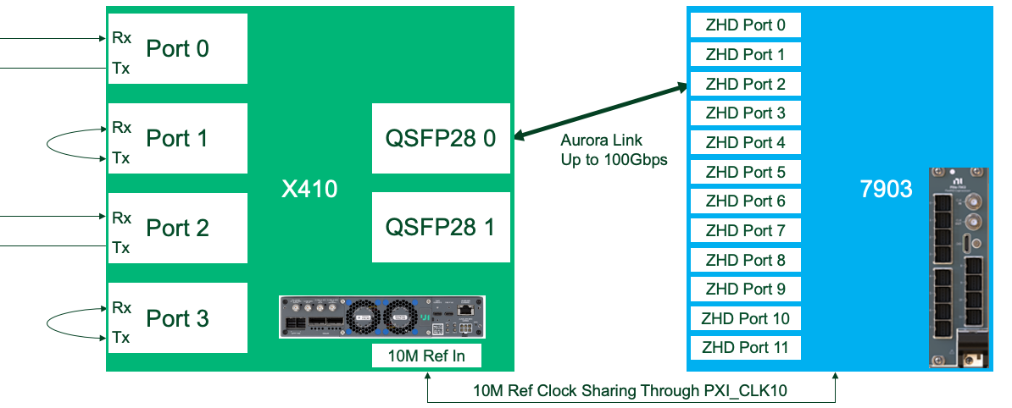
Figure 2: Connections between X410 and PXIe-7903 in the following demos

Demo 1: USRP X410 RF Rx Signal Receiver
X410 acts as pure RF front end
- 100Gbps Aurora streaming WITHOUT flow control on QSFP28 0
- Acquire 4Ch signals @ 491.52MS/s and forward to Aurora Tx channel
- Fetch signal data from Aurora Rx channel and generate 4Ch signals @ 491.52MS/s
- Monitor and report status on Aurora port and RF ports
PXIe-7903 acts as a co-processor
- 100Gbps Aurora streaming WITHOUT flow control on Port 2
- Fetch signals on Aurora Rx channel and loop them back to Aurora Tx channel directly
- Contain an MRA (Multi-Record Acquire) engine to acquire 4 channel signals per request and do analysis on host
- Monitor and report status on Aurora port
LabVIEW Front Pannel:
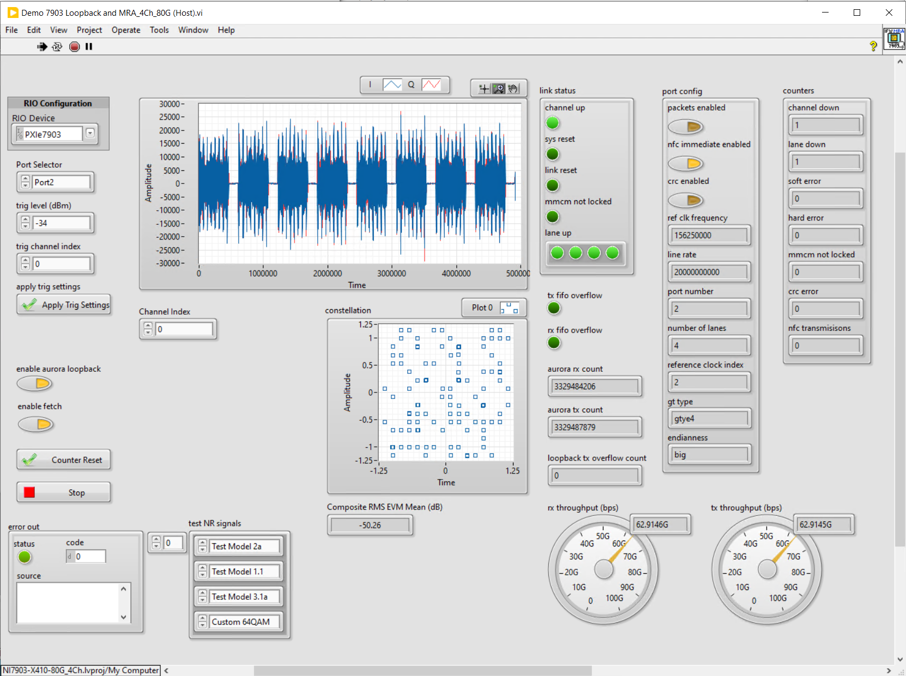
Figure 3: LabVIEW front panel of Demo 1

Demo 2: WaveGen on PXIe-7903 and Streaming to USRP X410 TX Signal Transmitter
- Flow control is expected for sending data from 7903 to X410
X410 acts as pure RF front end
- 80Gbps Aurora framing WITH flow control on QSFP28 0
  - Cannot get a successful build for 100Gbps
- Acquire 4Ch signals @ 491.52MS/s and forward to Aurora Tx channel
- Fetch signal data from Aurora Rx channel and generate 4Ch signals @ 491.52MS/s
- Monitor and report status on Aurora port and RF ports
PXIe-7903 acts WaveGen signal source and a co-processor
- 80Gbps Aurora framing WITH flow control on Port 2
- WaveGen engine on 7903 to generate four channel signals and send through Aurora link
- Fetch signals on Aurora Rx channel, MRA 4 channel signals per request and do analysis on host
- Monitor and report status on Aurora port
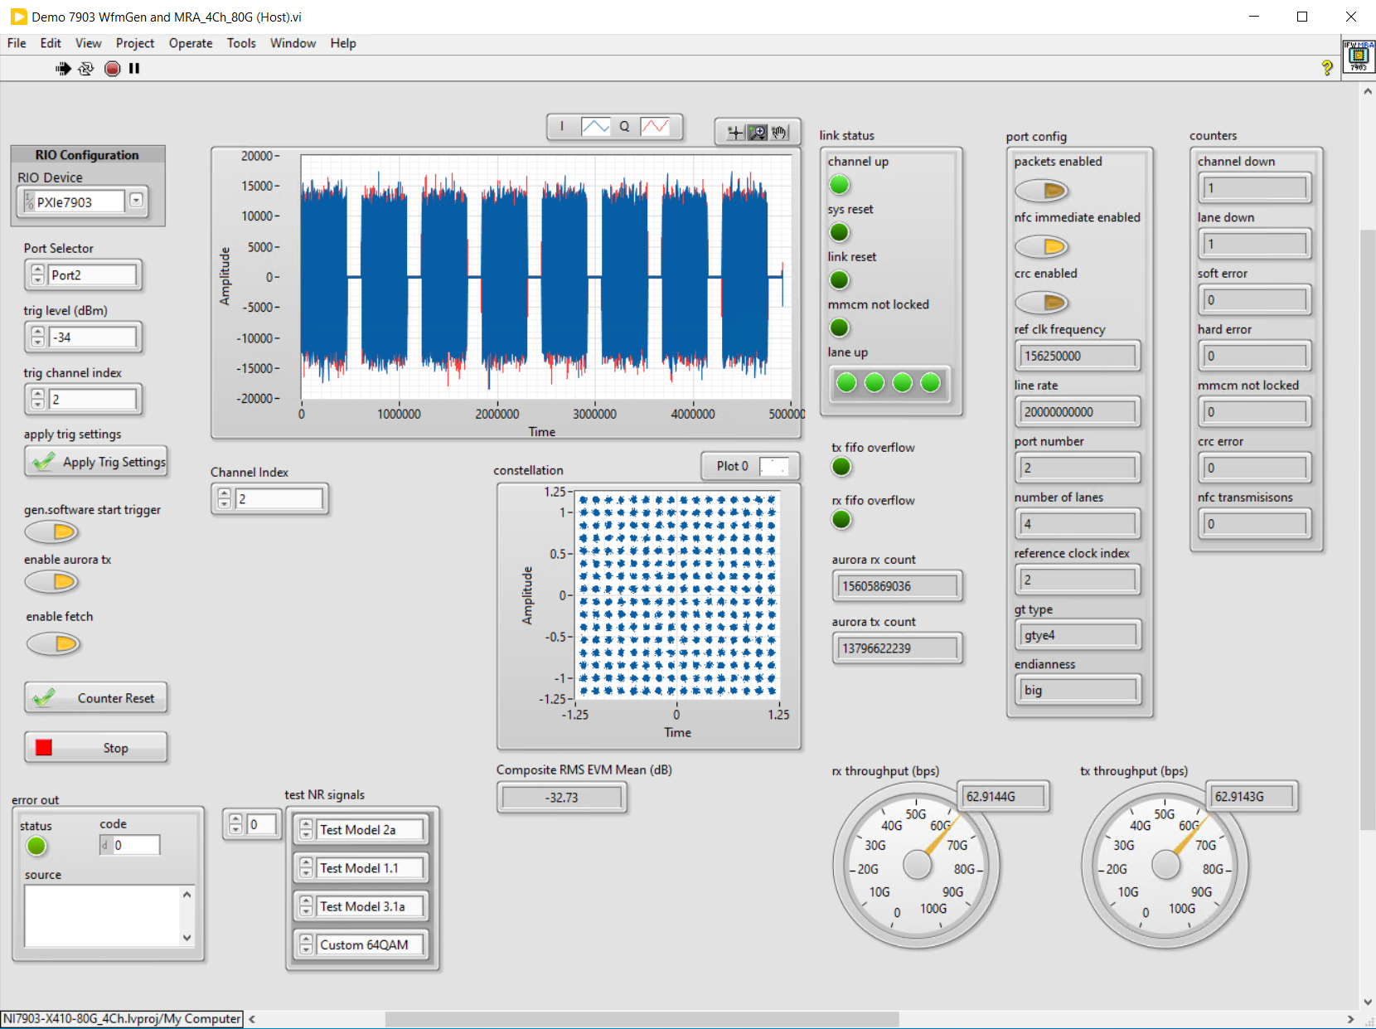
Figure 4: LabVIEW front panel of Demo 2

What’s in the Example

Flexible COnfiguration

X410 as RF front end and 7903/7902 as co-processor for comprehensive algorithm processing, such as MIMO communication with 4 channels at ~500MS/s IQ Rate (400MHz BW).

HW Requirements:
USRP X410 (up to 12 sets) | NI
PXIe-7903 and PXIe-7902 | NI
QSFP28 – MiniSaS HD cables | NI
(Optional) CDA-2990 | NI
SW Requirements:
RFSA 23Q4, RFSG 23Q4 | NI
NI-USRP 23Q3 | NI
NI-RFSA/NI-RFSG Instrument Driver for MGT Streaming (2023Q4) | NI
FlexRIO with Integreted I/O (2024 Q2) | NI
LabVIEW 2022Q3 | NI
LabVIEW FPGA 2022Q3 | NI
Figure 5: Hardware and software requirements
Demo Example Code:

Demo example codes of running the following Aurora links between X410 QSFP28 port and PXIe-7903/PXIe-7902 zHD ports  - 12.5Gbps streaming with flow control (7903/7902)  - 20Gbps streaming with flow control (7903 only)  - 25Gbps streaming without flow control (7903 only) | NI
Demo code running PRBS tests on the aurora link | NI
Demo code measuring latency of the aurora link | NI
Figure 6: What is included in the demo code

How?

Sales & Partner Enablement Resource Links

- IC4C xBU Platform Sales Enablement Page
- [Customer Facing Slides] USRP X410 and PXIe-7903 Streaming Example
- [Internal Training] Invitation to USRP X410 and PXIe-7903 Streaming Sharing - English
- [Video] USRP X410 and PXIe-7903 Streaming Example - Chinese
- [Demo] Source Code

Q&A

Q: What’s the difference between this demo example with X42x/7903 streaming example in Product R&D roadmap?

A: The Product R&D roadmap has a plan to release an example that will use UHD and RFNOC to control the USRP X410 and USRP X410 cannot be customized in LabVIEW FPGA. CIC’s work is pure LabVIEW toolchain, and customers can program the FPGA both in USRP X410 and PXIe-7903. We had a meeting aligned with product R&D before the development.

- End of Document –

